

**Object Oriented Programming Lab**

**Name:** Pratham Kandari

**Sap Id:** 500097663

**Batch:** 7

**Experiment -1**

**Title:** Introduction to Java Environment

1. **Java Versions:**

* JDK Alpha and Beta (1995)
* JDK 1.0 (January 23, 1996)
* JDK 1.1 (February 19, 1997)
* J2SE 1.2 (December 8, 1998)
* J2SE 1.3 (May 8, 2000)
* J2SE 1.4 (February 6, 2002)
* J2SE 5.0 (September 30, 2004)
* Java SE 6 (December 11, 2006)
* Java SE 7 (July 28, 2011)
* Java SE 8 (March 18, 2014)
* Java SE 9 (September 21, 2017)
* Java SE 10 (March 20, 2018)
* Java SE 11 (September 2018)
* Java SE 12 (March 2019)
* Java SE 13 (September 2019)
* Java SE 14 (March 2020)
* Java SE 15 (September 2020)
* Java SE 16 (March 2021)
* Java SE 17 (September 2021)
* Java SE 18 (to be released by March 2022)

**The version we will be working on is: Java SE 8**

1. **JDK and JRE:**

Java Development Kit (JDK) helps us to create Java Programs and applets and also helps us to compile the java programs using command javac i.e, java compiler.

Java Runtime Environment (JRE), a Java interpreter/loader helps us to run and execute the java programs if there is no error in compilation.

1. **Setting Path:**

**Step: 1** Go to the search box and type Environment Variables. Now, click on edit the system environment variables.

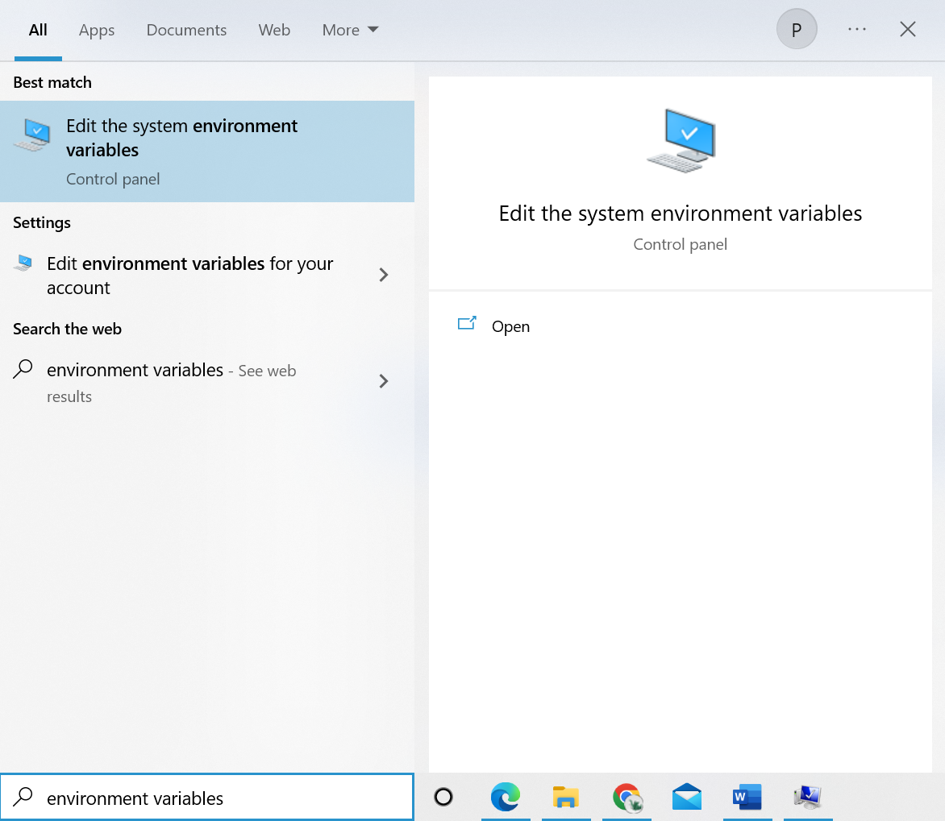

**Step: 2** Click on the Advanced Tab and then click on the Environment Variables.

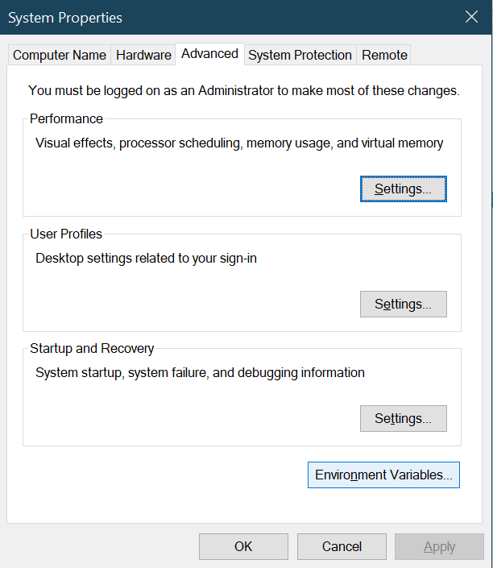

**Step: 3** In the System Variables click the New button.

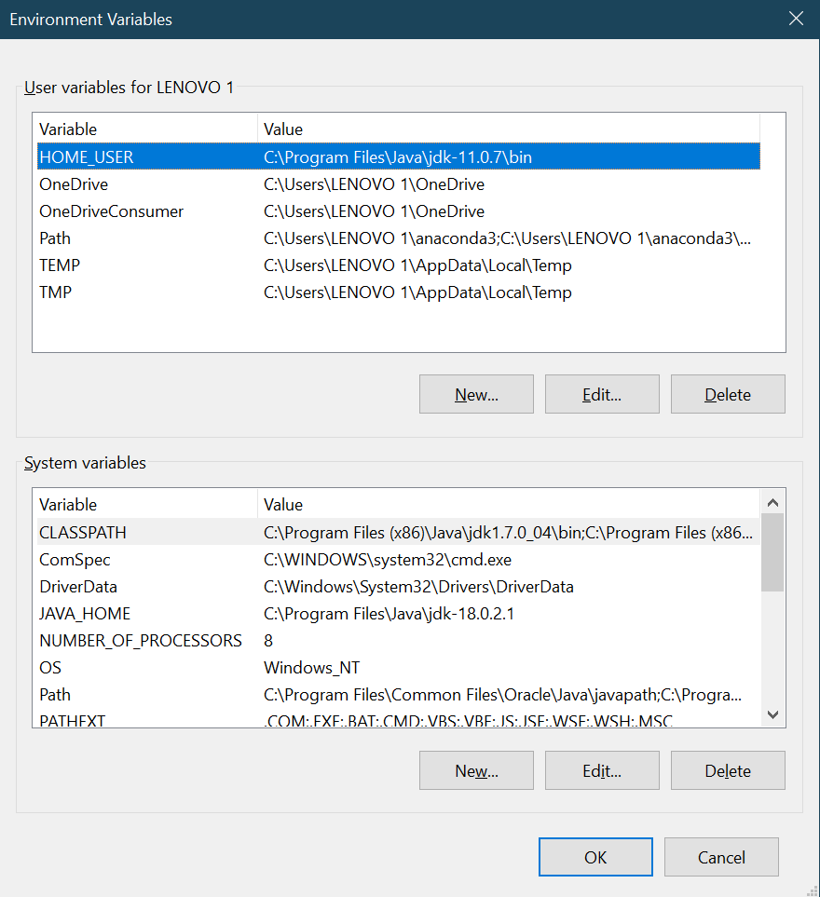

**Step: 4**  Now in the Variable name type JAVA_HOME and in the Variable value give the path of the jdk folder.

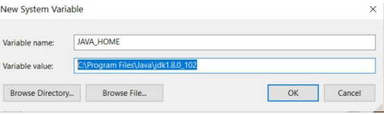

**Step: 5** Now in the System Variables go to the Path and click the edit button.

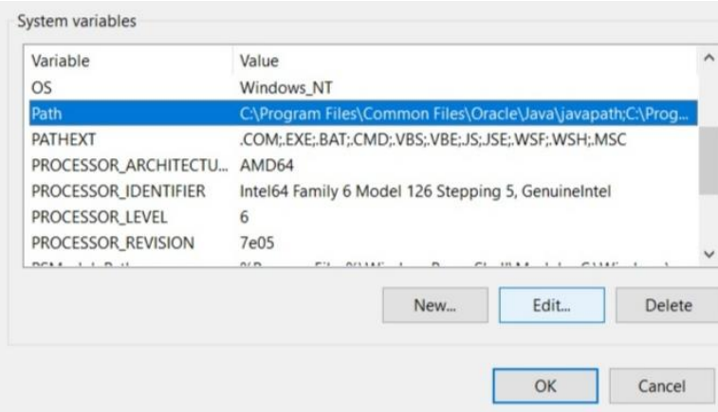

**Step: 6** Click the New button and copy the path of the jdk bin folder and click on ok.

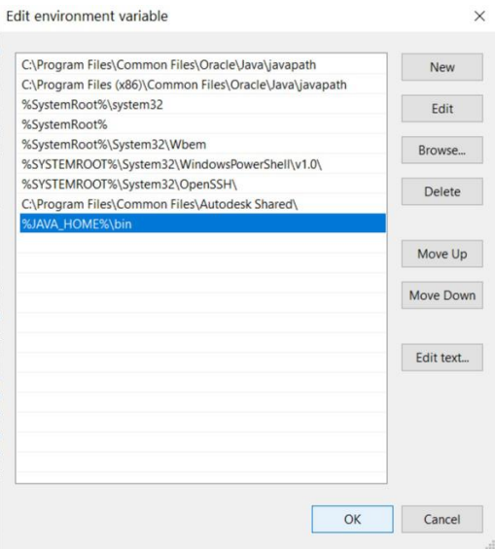

**Step: 7**  Now, to confirm that java has been installed in your system. Just open cmd and type **java –version**.

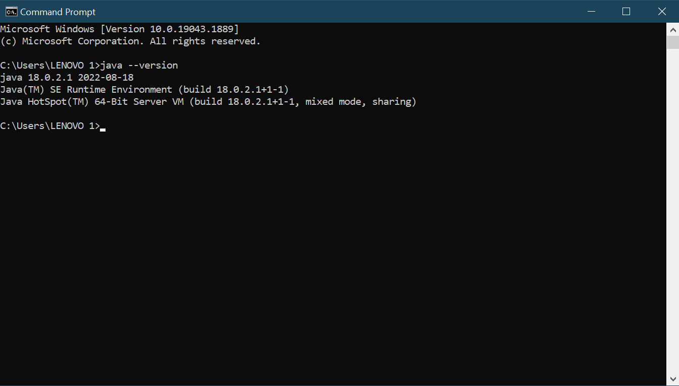

1. **Code Editors:**

Code Editors provide us with IDE (Integrated Development Environment) which is used to write java programs. Various code editors are available like VS Code, Eclipse, BlueJ, etc. I personally prefer VS Code.

1. **Sample Program:**

class Intro

{

public static void main(String args[])

{

System.out.println(“Hello World”);

}

}

